Table of Contents

1. Introduction 2
1.1 Objective of the Manual 2
1.2 Intended Audience 2
1.3 Organization of the manual 2
2. Getting Started in Revenue Leakage Platform 3
2.1 Login 3
3. Home Page 4
4. Dashboard 5
5. Facility Performance 8
5.1 BY Department 11
5.2 BY PATIENT TYPE 12
5.3 BY CHARGES 13
5.4 BY AUDITOR: 14
5.5 BY Financial class: 15
6. Auditor Performance 17
7. Supervision Tools 20
7.1 Live Summary 20
7.2 Auditor Assignment 22
7.3 Report User Assignment: 23
7.4 Additional auditor Queue List: 25
7.5 New Auditor Queue (Disabled) 27
7.6 View CDM 27
8. Auditor view 29
8.1 PRE-BILL ACCOUNT REVIEW LIST 30
8.2 POST-BILL ACCOUNT REVIEW LIST 32
8.3 Coding edits Accounts 35
8.4 View Confirmed charges 37
8.5 Edit Submitted Accounts 39
8.6 Submitted coding edits Accounts 41

1. Introduction

Revenue Leakage application is an intuitive application that works with your hospital’s existing system to find missing charges in patient accounts. It provides a simple user interface that allows an Supervisor to evaluate a prioritized list of patient accounts, auditor performance report and provide feedback. As it uses advanced machine learning, it adapts automatically, which means Supervisor doesn’t have to update the system when rules and regulations change.
Using this application, Supervisor can evaluate the auditor’s performance by viewing the comparison report of different auditors. He is able to see all Pre-Bill and Post-Bill prediction accounts of different hospitals across the system. He is able to see all charges that are identified during auditing process for selected hospital(s) for the date range.
Another important function of Supervisor is “User Management” which involves creating new users, modifying existing users, Enabling/Disabling the user accounts and resetting user passwords when needed.
The Supervisor is the privileged user who has the overall control of the application.
Revenue Leakage application is very user friendly and is an easy system to navigate.

1.1 Objective of the Manual
The objective of this manual is to provide assistance to the users ensuring effective use of the features and functionalities of the Revenue Leakage Platform application. The manual provides step-by-step descriptions of the functionality within the Dashboard, Facility performance, Auditor performance, Supervision tools, Edit Rules and User Management.
1.2 Intended Audience
This manual is intended for Supervisors and users of Revenue Leakage application. Access to the application is through the role and permission privileges
1.3 Organization of the manual
The Supervisor User Guide includes the following chapters:

- Dashboard
- Facility Performance
- Auditor Performance
- Supervision Tools
- Auditor View

2. Getting Started in Revenue Leakage Platform
  - Login

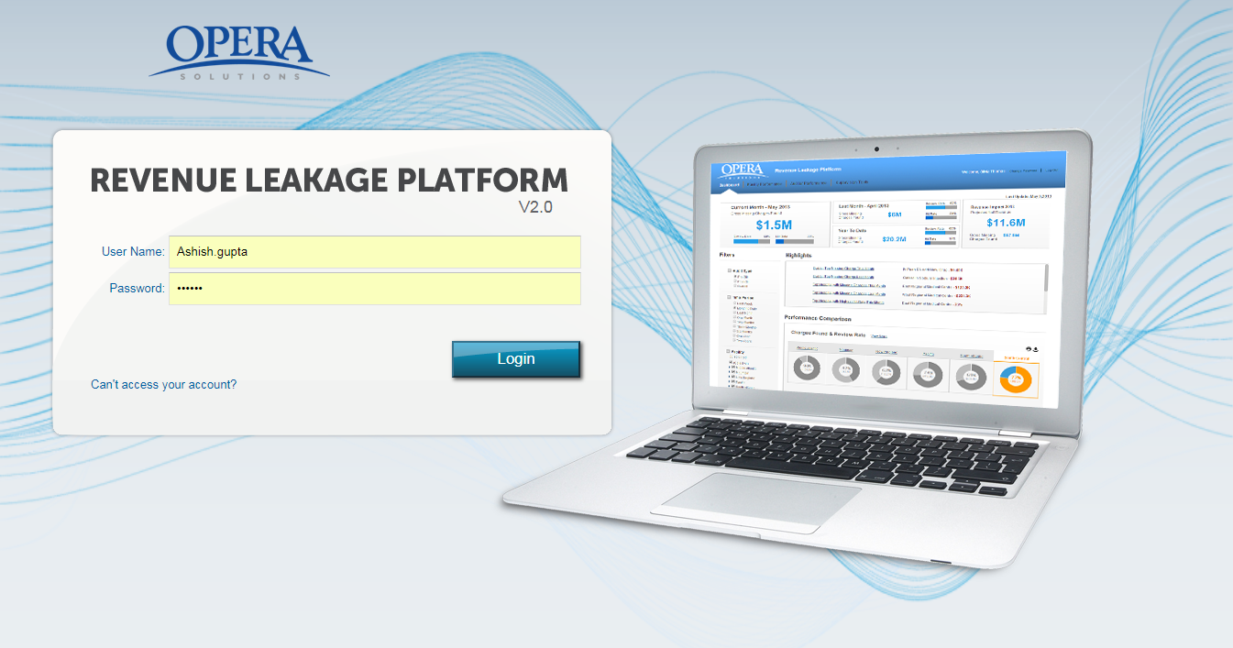
Step 1: The application can be accessed by entering the following URL into the address box:
_________________________________________
Step 2: Enter your “Username” and “Password”.
Step 3: Click “Login”.
Step 4: After entering the correct username and password, user is redirected to the Home page of Revenue Leakage Platform.
Note: Entering the wrong username and /or password three consecutive times will lock the account and then needs to be unlocked by other Supervisor.

- Home Page

The Home page has following five tabs. By default, “Dashboard” tab is selected.

  - Dashboard: The Dashboard provides a detailed overview of auditing process of different hospitals across various divisions. You are able to view details like the Review Rate and the Missing Charges of various hospitals based on the filter criterion selected.
  - Facility Performance: The facility performance feature enables you to analyse the performance of various facilities based on departments, patient types, charges and auditors. You will be able to track information like Review Rate, Hit Rate and the Missing Charges for different hospitals.
  - Auditor Performance: The auditor’s performance feature enables you to view the performance of the auditors, compare the Review and Hit Rate of auditors as per the total facilities assigned to them.
  - Supervision Tools: The supervision tools enable you to perform various operations like assigning auditors and searching auditors by their name. In addition, you are also able to view the information for Pre-Bill, Post- Bill and Account Review List.
  - Auditor View: The Auditor view enable you to view all the tabs related to Auditor view. We can track the account information based on auditor selected.
  - Analysis: The Analysis view enables you to view Analysis based on Hit rate and Volume. We can select method type, auditor and top codes.
  - Configuration: These rules are predefined in the Revenue Leakage application and help in getting better results for the various Missing Charges found across various hospitals.

- Dashboard

The Dashboard provides a powerful way to gain visibility and oversight into performance. You are able to analyse the efficiency of auditing process of different hospitals across various divisions. Based on the dashboard metrics, you can take proactive actions and can easily switch between different views of the data by selecting different filter parameters.

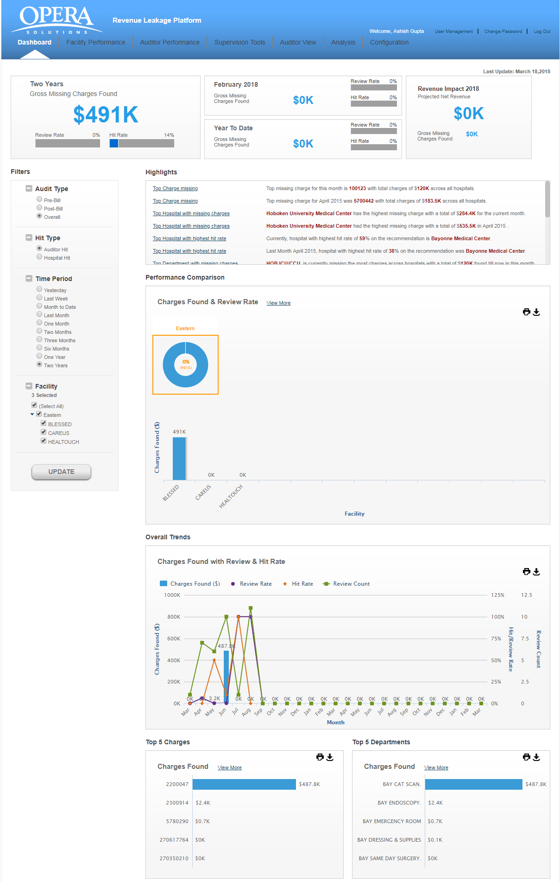
The upper left corner shows the “Gross Missing Charges Found”, “Review Rate” and the “Hit Rate” across all the hospitals.

For example, if the Review Rate of an auditor is 100%, it indicates that he has reviewed all the accounts which were assigned to him.
If the Hit Rate is 83%, it indicates that the auditor agreed on 83% of accounts which he reviewed for the missing charges.
On top right corner, you will view the “Projected Net Revenue” and the “Gross Missing Charges” for the current year.

You can specify filter options to display the data. Filtering can be done based on the following parameters:
- Audit Type
o Pre-Bill
o Post-Bill
o Overall
- Hit Type
o Auditor Hit
o Hospital Hit
- Time Period
o Last Week
o Month to data
o Last Month
o One Month
o Two Months
o Three Months
o Six Months
o One Year
o Two Years
- Facility

Based on the option selected, you can view the overall trend of Missing Charges and Hit Rate across various facilities. After selecting the filter, click on the “UPDATE” button. The application will populate the data in different widgets.

Highlights: This section highlights the Top Missing Charges/Review Rate of various hospitals. For example, Top Missing Charges this month, Top Missing charges last month etc.

Performance Comparison: You are able to view the data of different facilities across various divisions. In this segment, you will view following two charts:
o Donut chart: The donut chart shows the aggregated value of the “Hit Rate” and the “Missing Charges” of various hospitals based on the filter criterion selected.

o Bar chart: The bar chart shows the data related to different hospitals which fall under a particular division. If you place your mouse over the chart, a window pops up which shows the “Hospital Name”, Dollar found” and the “Review Rate” for individual hospitals.

Overall Trend: You are able to view the overall trend of facilities based on the filter criterion selected.
The Missing Charges found during a time period are shown as a bar chart.
The Review Rate across a time period is shown as a line graph.
The Hit Rate across a time period is shown as a line graph.
The X-axis shows the “Time Period”.
The Y-axis shows the “Charges Found” and “Review/Hit Rate”.
If you place your mouse over the graph, a window pops up this provides information about the “Charges Found”, “Hit Rate” and the “Review Rate”.

Top 5 Charges: This widget shows the “Top Five Missing Charges” across different hospitals based on the charge code. If you place your mouse over the charge code, a window pops up which shows the charge details like “Charge Code, “Charge Description” and the “Charges Found”.

Top 5 Departments: This widget shows the “Top Five Missing Charges” across different hospitals based on the department or department code. If you place your mouse over the department , a window pops up which shows the charge details like “Department”, “Hit Rate“ and the “Charges Found”

- Facility Performance

You are able to view the performance of different hospitals based on different parameters like departments, patient types, charges and auditor. Based on the past and current performances, you can set new goals and objectives for the coming year.
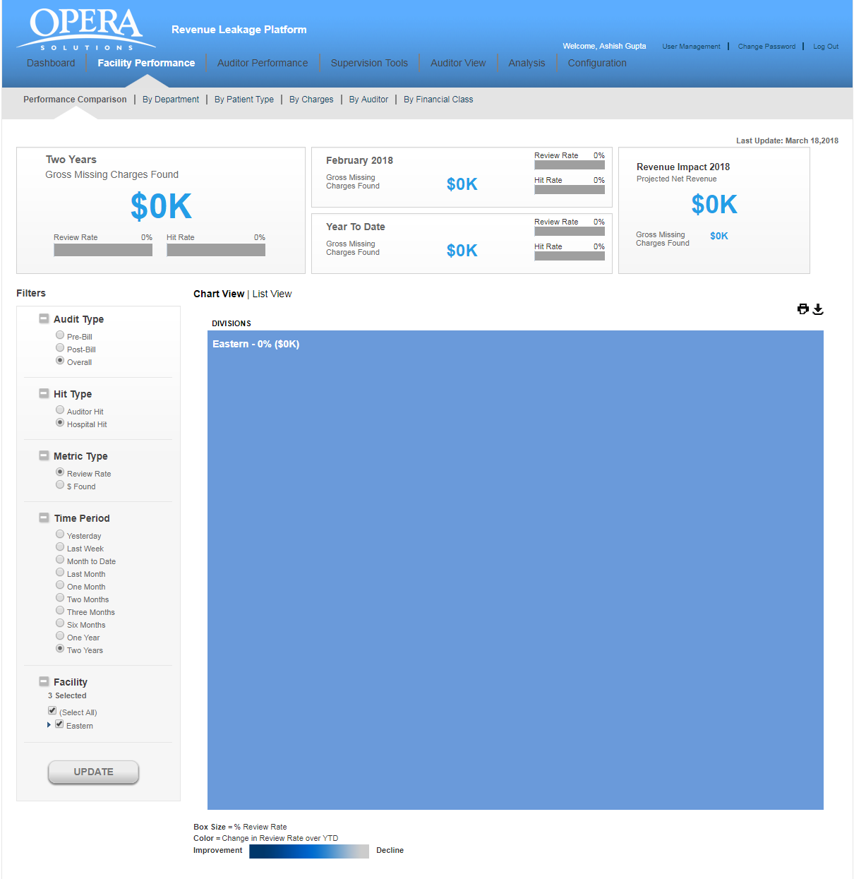

The upper left corner shows the “Gross Missing Charges Found”, “Review Rate” and the “Hit Rate” across all the hospitals based on selected filters (Audit Type, Metric Type, Time period and facility).

Next to it, you will view statistics for “Review” and “Hit rate” for the last month.
“Projected Net Revenue” is the revenue expected to be earned in future and is calculated based on the previous reporting periods.

The top right corner shows the “Projected Net Revenue” and the “Gross Missing Charges” for the current year.
You can specify filter options to display the data. Filtering can be done based on the following parameters:
- Audit Type
o Pre-Bill: If you choose this option, you will view the data for Pre-Bill accounts.
o Post-Bill: If you choose this option, you will view the data for Post -Bill accounts.
o Overall: If you choose this option, you will view the data for both Pre-Bill and Post-Bill accounts.

- Metric Type:
o Review Rate: If you choose this option, you will view the Review Rate of hospitals followed by missing charges.
o $ Found: If you choose this option, you will view the Missing Charges followed by Review rate of hospitals.

- Time Period: Select any time period from the given options. Based on the Time Period selected, it will display the details. For example, selecting “Three Months” option will display the data for last three months.
o Last Week
o Month to data
o Last Month
o One Month
o Two Months
o Three Months
o Six Months
o One Year
o Two Years

- Facility: If you choose the option “SELECT ALL”, all divisions and various hospitals which fall under those divisions will be selected. You may select a specific division for viewing the information.

After selecting the filter option, click on the “UPDATE” button. The data will be displayed in following two forms:
1. Chart View: When you click the “Chart View” option, you will see the filtered view of the data for selected divisions and time period.

On clicking a particular division, the application will display the data of all hospitals which fall under that division.

For example, if you select “Metric type” as “Dollar Found per day”, all the hospitals will show the “Dollar” amount found per day followed by “Hit Rate” in parentheses.
If the Metric selected is “Hit Rate”, all the hospitals will show the “Dollar” amount found per day followed by “Hit Rate” in parentheses.
The box size of various facilities\hospitals is dependent on the variance value. It is the dollar found per day over year to date period. Greater the value of dollar found, bigger would be the box size.
All the hospitals are shown in different shades and the shade is again dependent on the variance value. Higher the variance value, darker would be the shade. If you place your mouse over the box, you will view “Dollar “found, “Hit Rate” with change in average dollar found over “Year- to- Date” period.

2. List View: When you click the “List View” option, you will see the data of different hospitals in tabular format.

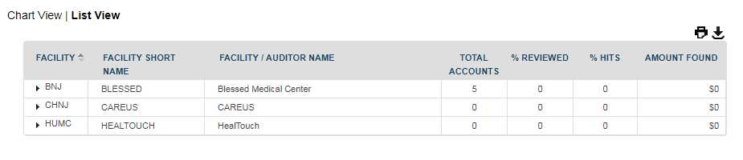
You will get the snapshot of total accounts assigned to an auditor, Accounts Reviewed, Hit Rate and the Missing Charges found across that facility. 12

5.1 BY Department

When you click the option “By Department”, you will see the performance of different hospitals based on various departments. You can change the view by selecting the desired filters and clicking on “UPDATE” button.

Click any column title to change the sort order of the list. The upward triangle indicates ascending sort (A to Z and 0 to 9). The downward triangle indicates descending sort order (Z to A and 9 to 0)
Following two icons are available on right side for downloading and printing the reports.
- Print: The Print button () is used for taking printout of the reports.
- Download: The Download button is used for downloading the report in excel or PDF format.
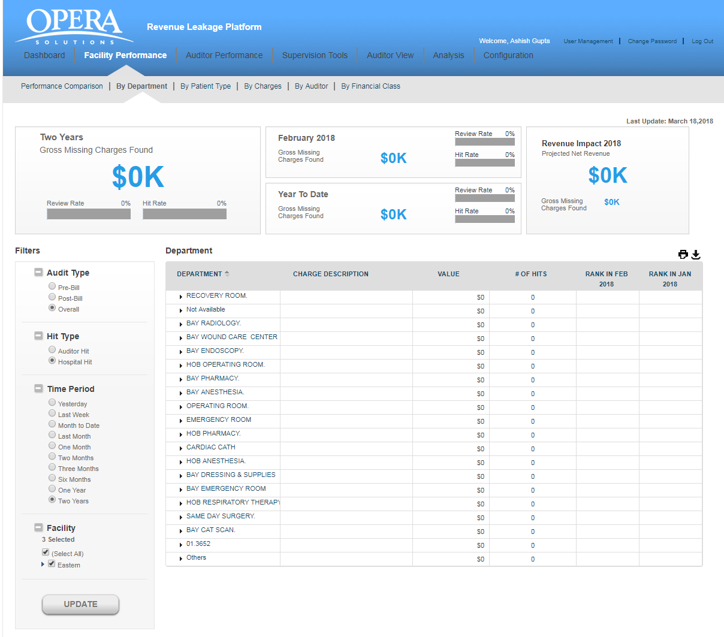
You will view various departments’ data in tabular format:
- DEPARTMENT: This shows the name of the department which auditor has audited.
- $ VALUE: This shows the missing charges found in that department.
- # Of HITS: This shows the number of agreed cases out of the total cases assigned to an auditor in that particular department.
- RANK IN JUL 2013: It shows the department ranking for last to last month.
- RANK IN JUN 2013: It shows the department ranking for previous month.

5.2 BY PATIENT TYPE

When you click the option “By Patient Type”, you are able to view the performance of different hospitals based on different patient types. 14

You can change the view by selecting the desired filters and clicking on “UPDATE” button.
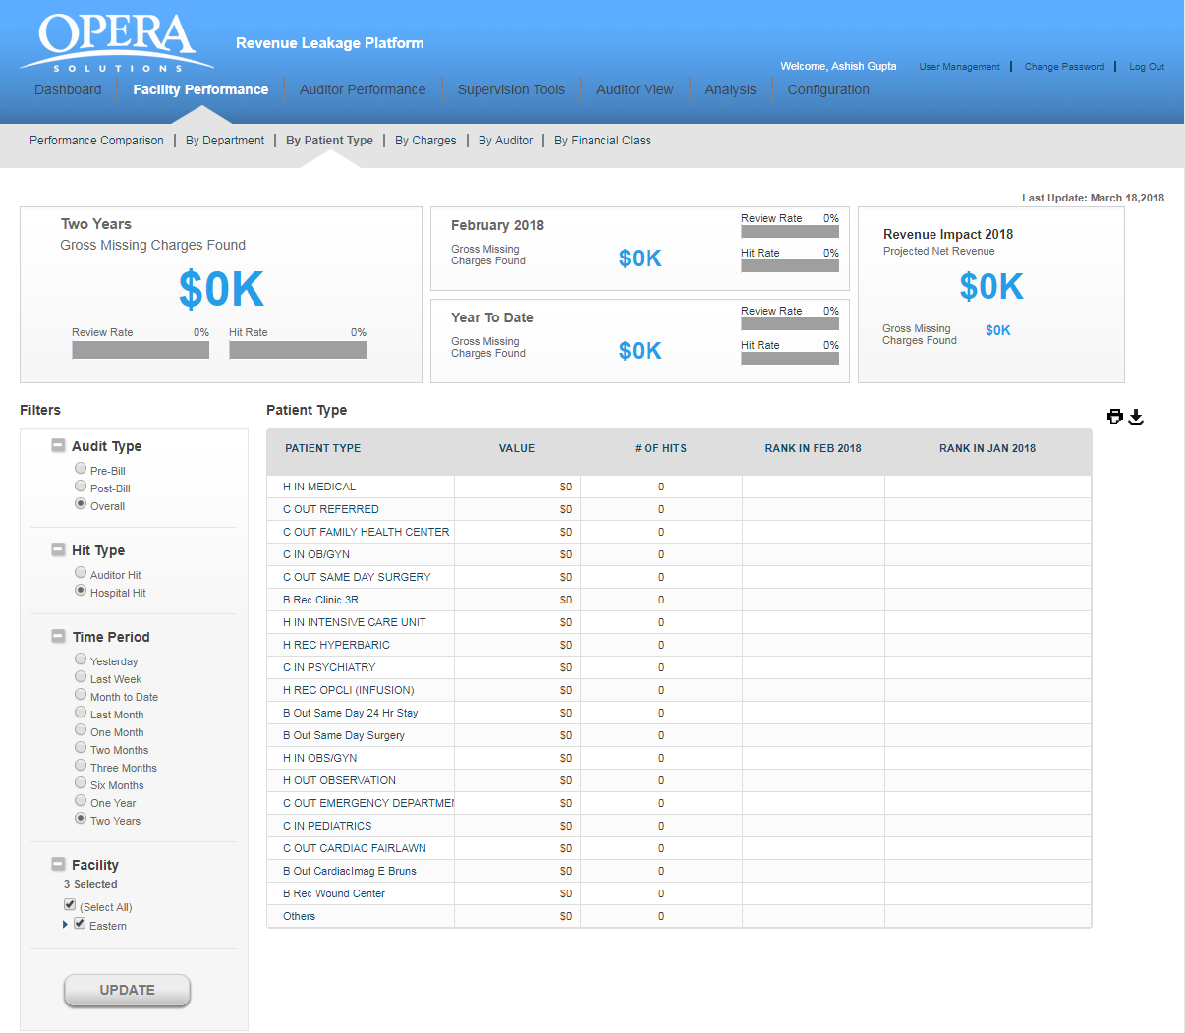
You will view the patient’s data in tabular format:
- PATIENT TYPE: It refers to different patient types like emergency, surgery etc.
- $ VALUE: These are the missing charges found for a specific patient category.
- # Of HITS: This shows the count of agreed cases out of the total cases assigned to an auditor for different patients.
- RANK IN JUL 2013: It shows the patient’s ranking for last month.
- RANK IN JUN 2013: It shows the patient’s ranking for last to last month.

5.3 BY CHARGES

When you click the option “By Charges”, you are able to view the auditor’s performance based on different charge codes. You can change the view by selecting the desired filters and clicking on “UPDATE” button.
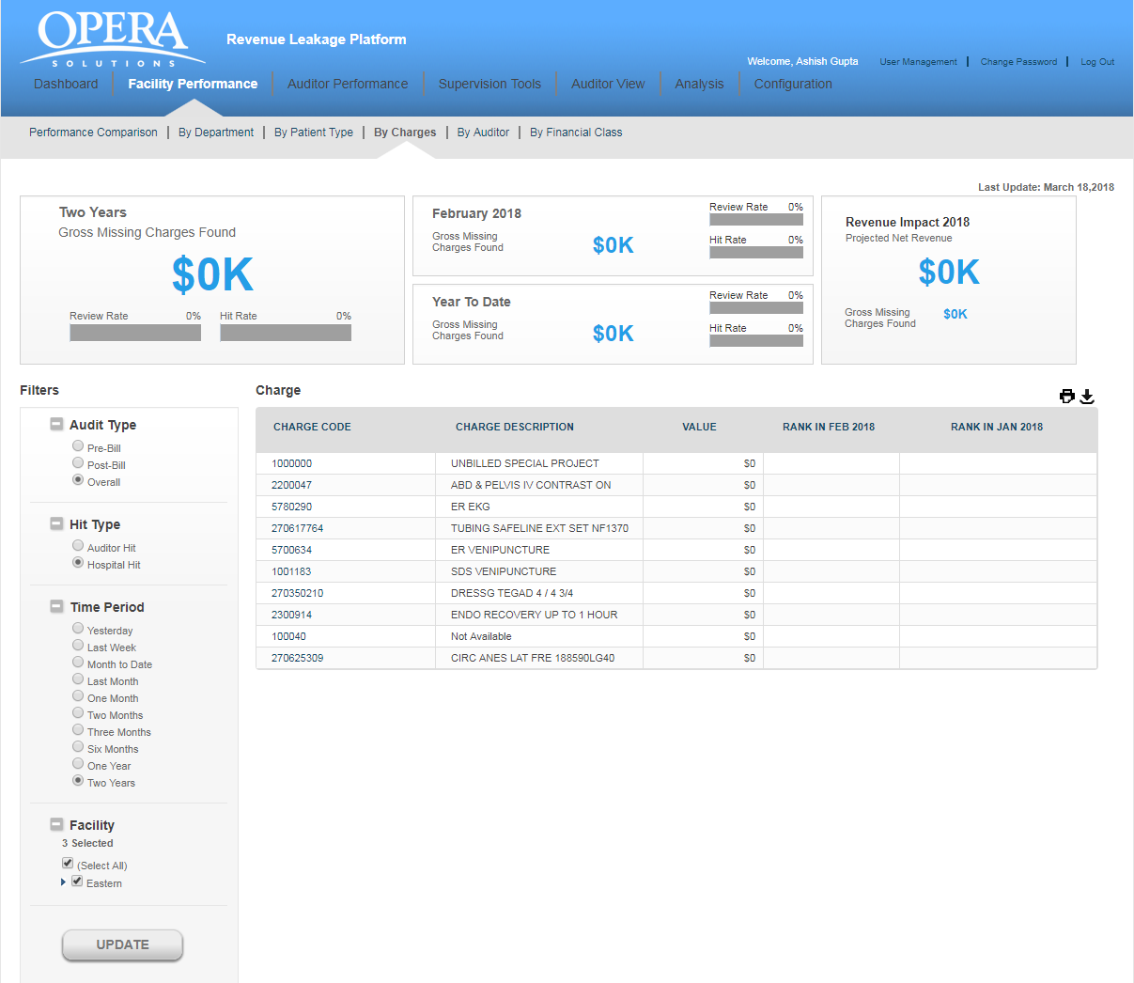

Based on the filter option selected, you can view the charge code, dollar value found against that charge code and its ranking.

5.4 BY AUDITOR:

When you click on the option “By Auditor”, the application will display the comparative data of various auditors.
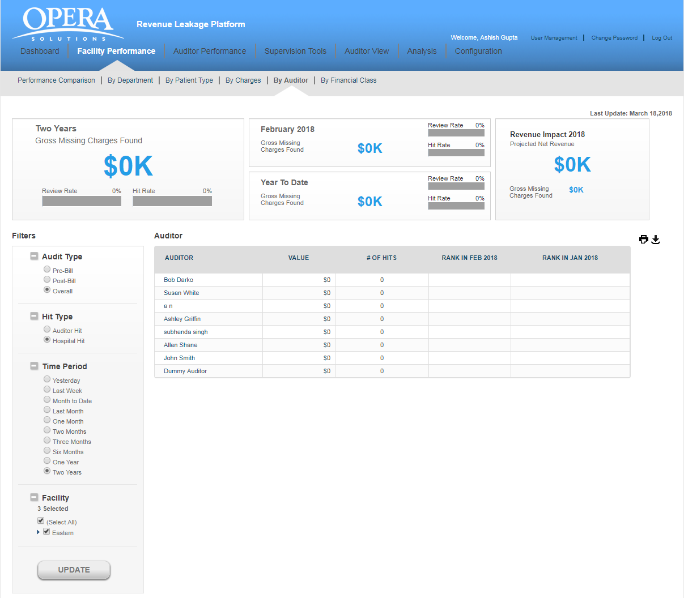

You will view the auditor’s data in tabular format:
- AUDITOR: This is the name of the auditor.
- $ VALUE: These are the missing charges found by the auditor.
- # Of HITS: This shows the value of agreed cases out of the total cases assigned to an auditor.
- RANK IN AUGUST 2013: It shows the auditor’s ranking for previous month.
- RANK IN JULY 2013: It shows the auditor’s ranking for last to last month.

Click any column title to change the sort order of the list.

5.5 BY Financial class:

When you click on the option “By financial class”, the application will display the comparative data of various financial class.
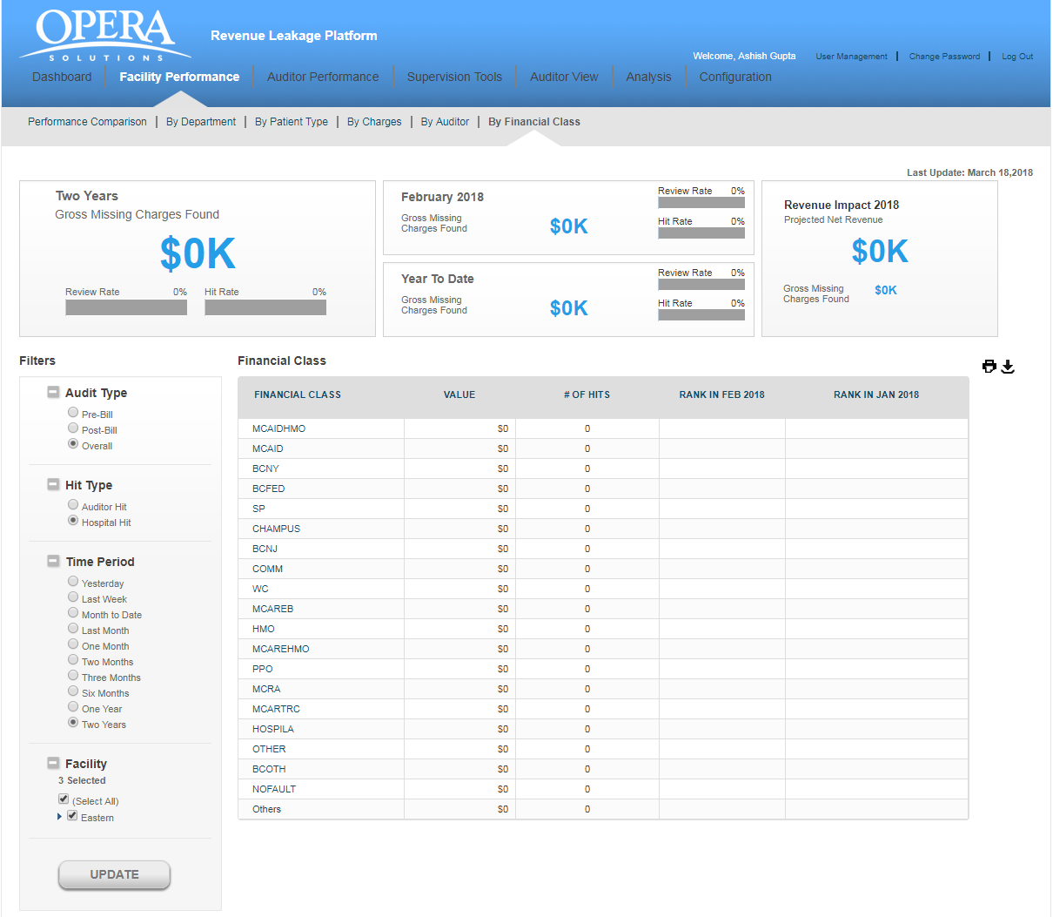

You will view the auditor’s data in tabular format:
- FINANCIAL CLASS: This is the name of the financial class.
- $ VALUE: These are the missing charges found by the auditor.
- # Of HITS: This shows the value of agreed cases out of the total cases assigned to an financial class.
- RANK IN AUGUST 2013: It shows the financial class ranking for previous month.
- RANK IN JULY 2013: It shows the financial class ranking for last to last month.

Click any column title to change the sort order of the list.

- Auditor Performance
You can evaluate the performance of different auditors; track the output and measure auditor’s contribution by assessing changes across various facilities. It helps to improve auditor’s performance and achieve results.
The upper left corner shows the “Gross Missing Charges Found”, “Review Rate” and the “Hit Rate” across all the hospitals based on selected filters.
Next to it, you will view statistics for “Review” and “Hit rate” for the last month.
Top right corner shows the “Projected Net Revenue” and the “Gross Missing Charges” for the current year.
Based on the filters selected, you will be able to view and compare the Auditor’s Performance. 18

Auditor Performance Trend: You can view the auditor’s report chart by clicking on the tab “Auditor Performance Trend”. (For example, below screenshot shows the trend for the Auditor “Cathy Pipkin”).

“Time Span” is shown on the “X axis” and “Charges Found” is shown on the “Y axis”.
“Missing dollars” found across a time period are shown as bar chart.
The blue line shows the “Review Rate” of an auditor for the selected time period.
The brown line shows the “Hit Rate” for the selected time duration.
If you place your mouse over the bar graph or the line graph, a tool tip appears which shows the data for “Charges Found”, “Hit Rate” and the “Review Rate” for that particular month.

Auditors Comparison: You can compare the efficiency of different auditors by clicking on the tab “Auditors Comparison”. The application will display the data of all the auditors, Total Accounts assigned, Accounts Reviewed and Missing Dollars found by individual auditors.

The data is displayed in tabular format which has following columns:
- AUDITOR NAME: This is the name of the auditor.
- TOTAL FACILITIES ASSIGNED: Total facilities which are being assigned to the auditor.
- TOTAL ACCOUNTS: Count of all the accounts across all the hospitals which are being assigned to the auditor.
- % REVIEWED: This is the percentage of accounts reviewed by the individual auditor.
- %HITS: This is the percentage of accounts on which the auditor has agreed for missing charges.
- $ VALUE OF HIT: These are the missing charges found by the auditor.

Click any column title to change the sort order of the list.

- Supervision Tools
The Supervision tools enables you to perform different operations like delegate auditors to different hospitals, examine all Pre-Bill, Post-Bill accounts and all the Missing Charges. It will uncover issues that are causing problems in various facilities and on which the action should be taken.
Clicking on “Supervision Tools”, displays four sub tabs:

- Live Summary
- Auditor Assignment
- Report User Assignment
- Additional auditor queue list
- New Auditor Queue
- Global Account Search

  - Live Summary
You will tree view two types of the data in a tabular format:
- By Facility
- By Auditor
By Facility –
You will view the data in a tabular format which contains following columns:
- FACILITY: This is a unique identifier and is assigned to each facility.
- FACILITY / AUDITOR NAME: This is the name of the parent facility and child auditors.
- TOTAL ACCOUNT: This is total account in the facility. Child is showing the accounts assigned to auditor.
- #COMPLETED: Count of account completed by Auditors.
- % REVIEWED: percentage of account reviewed by Auditors.
- # REMAINING: Count of account remaining by Auditors.
- # HIT ACCOUNTS: Count of account hit by Auditors.
- AMOUNT FOUND: Amount found by Auditors.

By Auditor
You will view the data in a tabular format which contains following columns:
- AUDITOR: This is a unique identifier and is assigned to each auditor.
- FACILITY NAME: This is the name of the facility.
- TOTAL ACCOUNT: This is total account in the facility.
- #COMPLETED: Count of account completed by Auditors.
- % REVIEWED: percentage of account reviewed by Auditors.
- # REMAINING: Count of account remaining by Auditors.
- # HIT ACCOUNTS: Count of account hit by Auditors.
- AMOUNT FOUND: Amount found by Auditors.

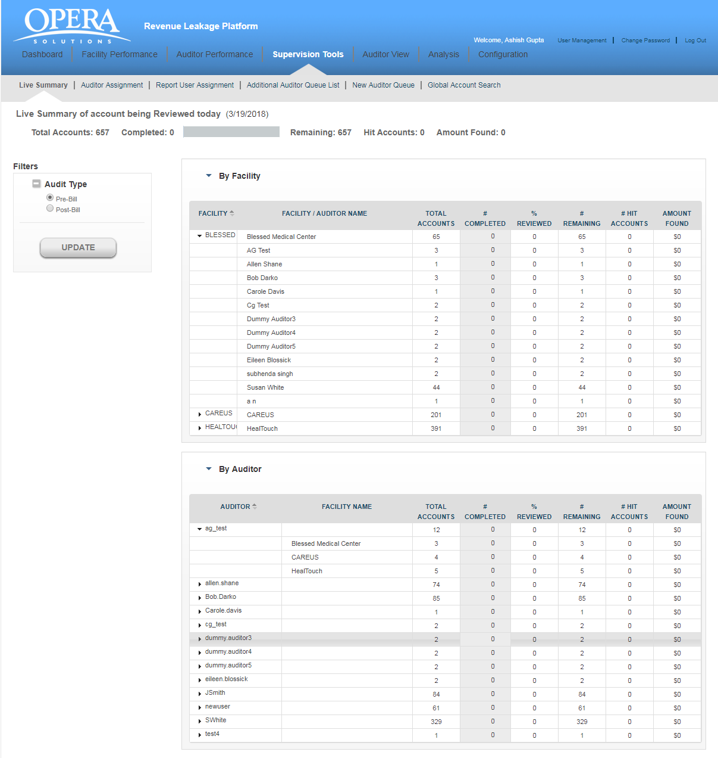

7.2 Auditor Assignment:

You will view the data in a tabular format which contains following columns:

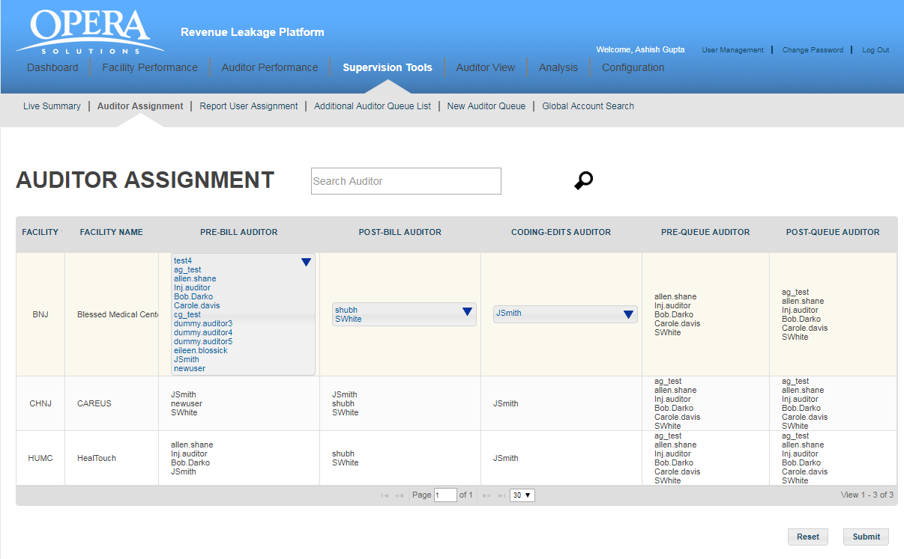

- FACILITY: This is a unique identifier and is assigned to each facility.
- FACILITY NAME: This is the name of the facility.
- PRE-BILL AUDITOR: This auditor is assigned for Pre-Bill accounts audit.
- POST-BILL AUDITOR: This auditor is assigned for Post-Bill accounts audit.
- CODING-EDITS AUDITOR - This auditor is assigned for rule based Pre accounts audit
- PRE-QUEUE AUDITOR - This auditor is assigned for Pre-queue accounts audit
- POST-QUEUE AUDITOR - This auditor is assigned for Post-Bill accounts audit

You can assign/unassign auditors to different hospitals depending on the requirement.
Click on the down arrow shown against the auditor’s name and you will get a complete list of auditors. Select the checkbox to the left of the auditor’s name and click “Submit “button. That auditor will be assigned to the facility.
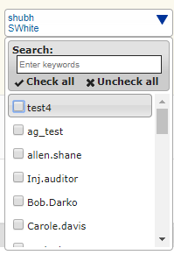

Search: You can use the “Search” box to quickly find an auditor. For example, if you want to search for the auditor” Inj. Darko”, type the initial letters in the text box provided, you will get a list of auditors whose first name starts with the letters you have typed. Select the auditor whose details you want to view and click on the “Search” button. The application will display all the hospitals which are assigned to the auditor ( “Inj. Darko” )

7.3 Report User Assignment:

You will view the data in a tabular format which contains following columns:

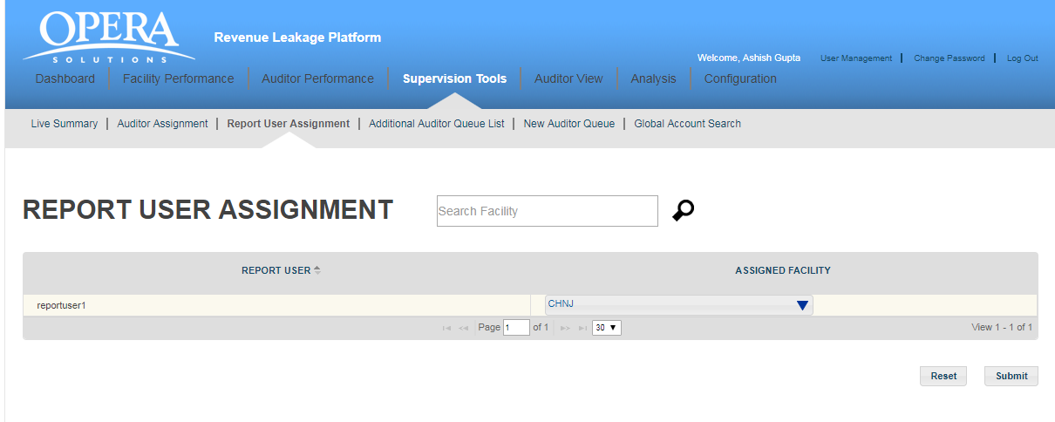

- Report User: This is a unique identifier and is assigned to each facility.
- Assigned facility: This is the name of the facility.

You can assign/unassign facility to different auditor depending on the requirement.
Click on the down arrow shown against the facility name and you will get a complete list of facility. Select the checkbox to the left of the facility name and click “Submit “button. That facility will be assigned to the auditor.
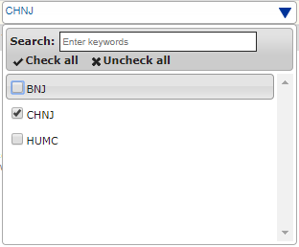
Search: You can use the “Search” box to quickly find an facility. For example, if you want to search for the facility” BNJ”, type the initial letters in the text box provided, you will get a list of facility whose first name starts with the letters you have typed. Select the facility whose details you want to view and click on the “Search” button. The application will display all the hospitals which are assigned to the facility ( “BNJ” )

7.4 Additional auditor Queue List:

Additional auditor queue list shows all the queues created for the application in tabular form. For searching a queue from the list, you can enter first few initials and application will show you the matching results. Also, you can update priority and assign auditor queue from here.
You will view the data in a tabular format which contains following columns:
- QUEUE NAME: This is the name of the queue created.
- AUDITOR: This is the name/s of the auditor/s which are assigned for this queue.
- BILL-TYPE: This is the Bill-type information (PRE/POST)
- PRIORITY: This is the priority of the queue execution. Execution of the queue depends on the priority number; lowest number priority queue will execute at the last. So, for the queue which should execute after other queue executions should be least priority number.
- STATUS: This is the status of the queue it can be active or inactive.

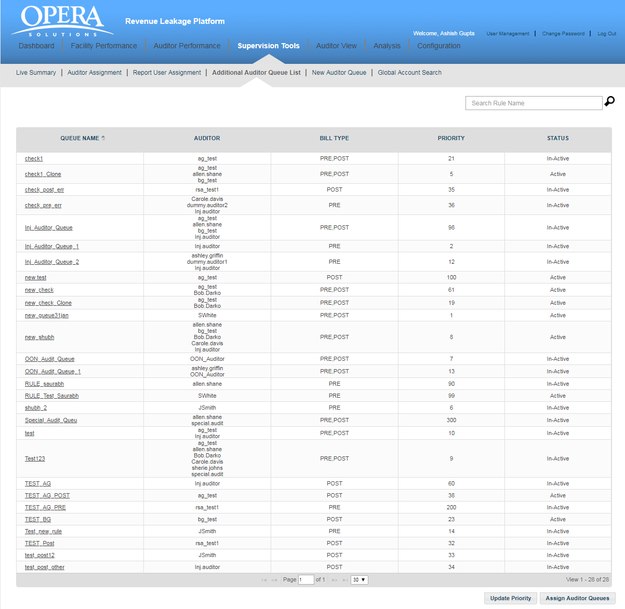
On clicking any queue name user will navigate to details screen. Here, you have “Auditor Queue Details” and “Rule Conditions” section for the queue. Administration user can only make queue active or inactive and make other modifications under “Auditor Queue Details” section, queue name field remain read only.
Supervisor user can modify rule condition as per the requirement. You have following buttons available for the rule at the bottom of the screen.
- CLONE: Supervisor user can create new queue using clone feature, if he wants to create a new queue like the existing queue, he can modify the queue name and rule condition as required for new queue.
- PREVIEW: User can view what all the accounts flagged as per the rule condition by using PREVIEW feature. An excel document listing all the accounts will display and accounts having rule flag is “Y” are those who satisfy this queue. Using this feature Supervisor can analyse created queue effectiveness before applying in the application.
- JSON: User can view the rule condition in JSON format using JSON feature.
- SQL: User can view underneath SQL query created for the rule using this button.
- SUBMIT: Supervisor user can save changes in the queue using submit button.

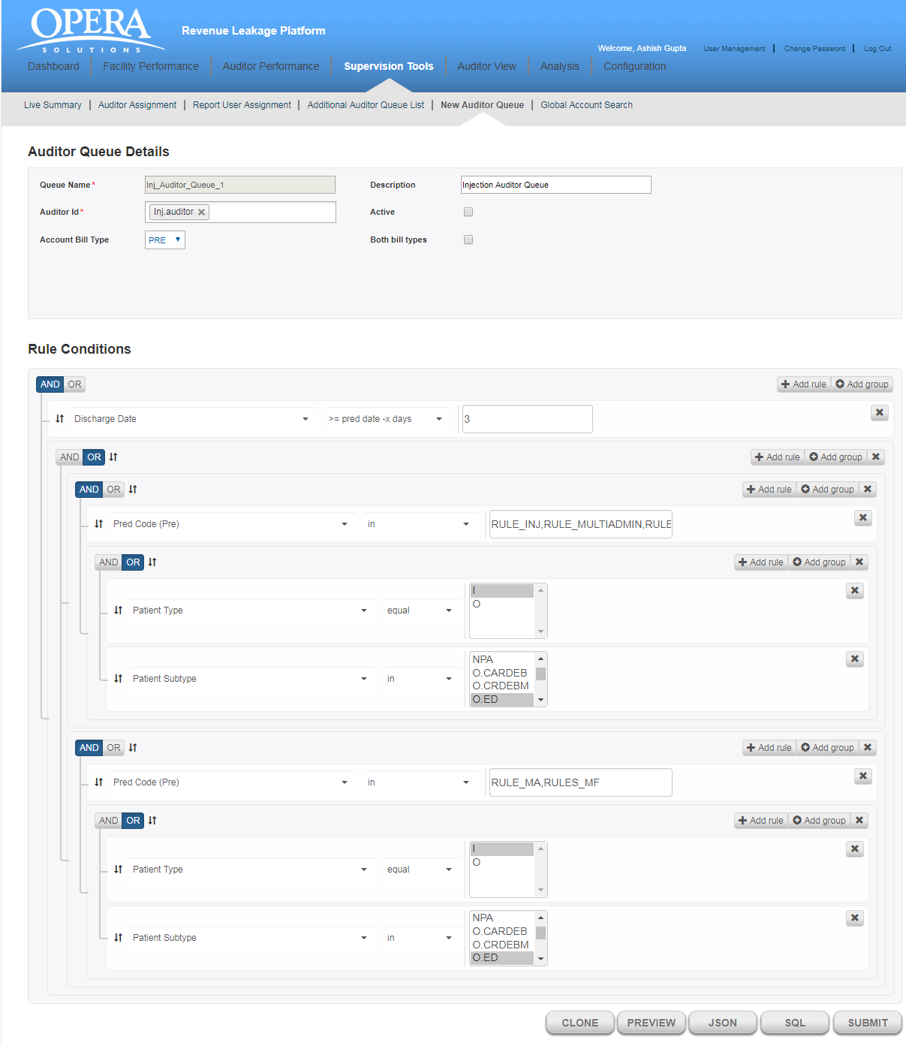

7.5 New Auditor Queue (Disabled)
7.6 View CDM
This section is basically used to verify/modify in charge master data. We can view, change, delete and edit the charge master data.
Below are the list of fields which can used for searching in charge master file
- Facility Id
- HCPC
- Service code
- Modifier
- Department Code
- Revenue Code
- Service Description
Initially it is giving top 1000 records in CDM file. Below screen-shot is showing the tabular data of CDM file.
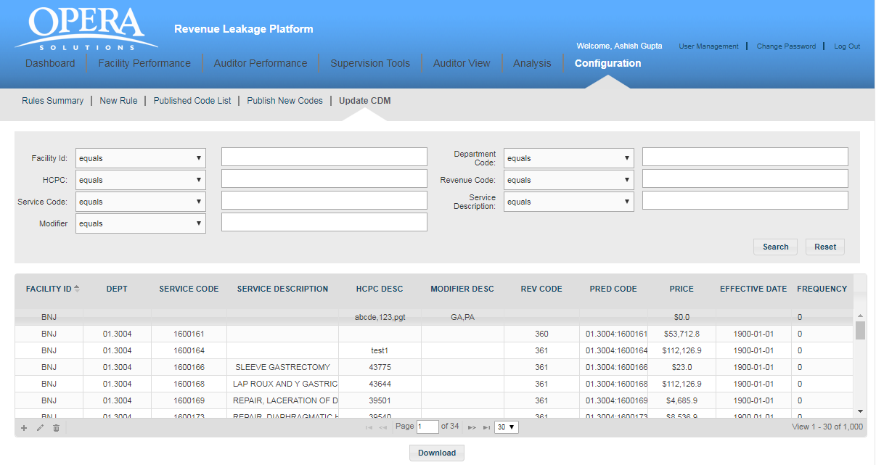
Filter the records – In below screen-shot we are filtering the data based on Service code (1600161).
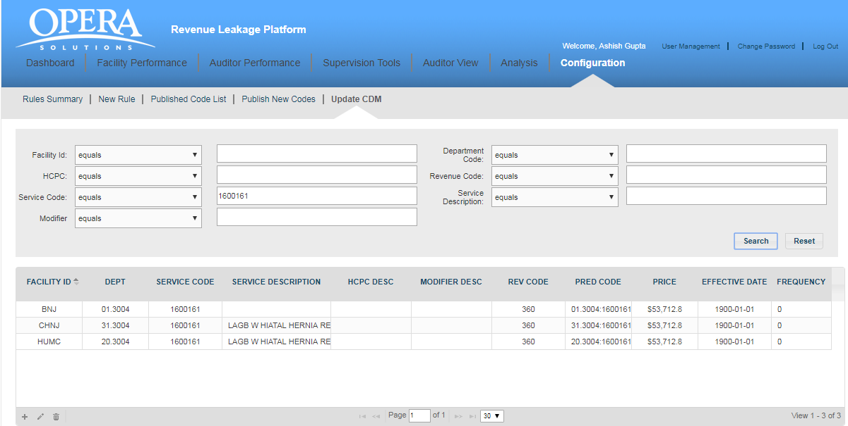
View CDM entry. Below icons images are present in grid bottom-left corner.
In Supervisor, we can only view the CDM records. View button is available on bottom-left corner of the grid. We can navigate view using button available on bottom on pop-up.

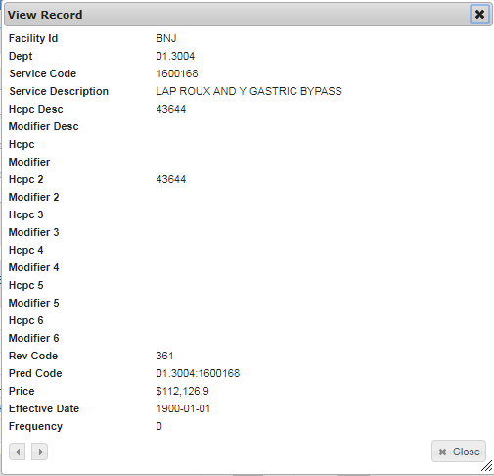

- Auditor view
The Auditor tools enables you to perform different operations like delegate auditors to different hospitals, examine all Pre-Bill, Post-Bill accounts and all the Missing Charges. It will uncover issues that are causing problems in various facilities and on which the action should be taken.
Clicking on “Auditor”, displays four sub tabs:

- Pre-Bill Account Review List
- Post-Bill Account Review List
- Coding Edits
- View Confirmed Charges
- Edit Submitted Accounts
- Submitted Coding Edits

8.1 PRE-BILL ACCOUNT REVIEW LIST

It shows all the PRE-BILL accounts of different hospitals which have been assigned to an
auditor. For viewing accounts of a particular hospital, select the hospital ID and Auditor from the filter panel available on the left side and the application will display all the accounts of that particular facility.

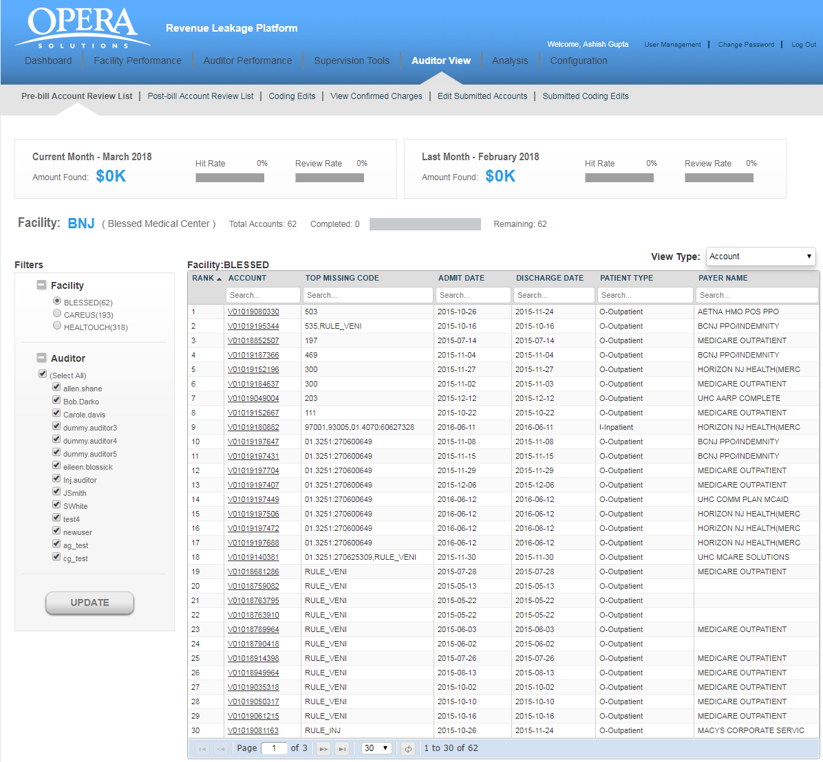
If no account is pending for review, the auditor will get the message “No Account Review is
“Pending for the Facility”.

View Type : Grouping accounts based on Code and payer. There are 3 options available in dropdown.
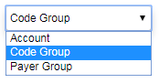
- Account (Default)
- Code Group
- Payer Group
Account : This the default view for showing accounts. accounts are coming based on hospitalId and accountId
Code Group: - This is showing tree view of accounts based on [hospitalId-accountid-predcodeClassifications]. 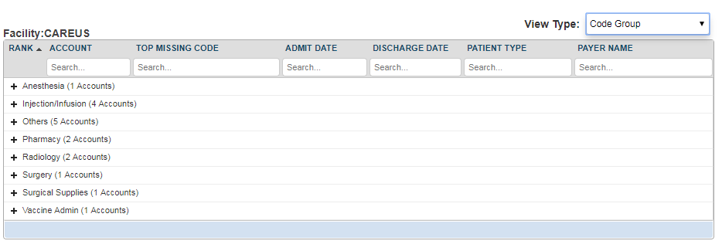
Payer Group:- - This is showing tree view of accounts based on [hospitalId-accountid-PayerCode].
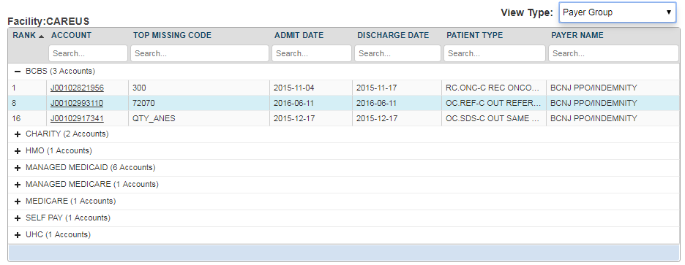
You will view the following details for a particular account.
- Account: It refers to the patient identification number.
- Top Missing Code: It refer to the missing code find for this account.
- Admit Date: It is the date when patient got admitted to the hospital.
- Discharge date: This is the date when patient got discharged from the hospital.
- Patient Type: There can be different types of patients. For example, OUTPATIENT, INPATIENT and EMERGENCY.
  - OUTPATIENT care is any healthcare service provided to a patient who is not admitted to a hospital.
  - INPATIENT care is any healthcare service provided to a patient who is admitted to a hospital.
  - EMERGENCY care is provided to the patients who need urgent care because of the illness or accident.
- Payer Name: This is the name of the insurance company.

All the above fields are searchable. You can navigate through multiple pages of records by making use of navigation bar given at the bottom of the screen. Enter a specific page number and you will jump to that specific page.

Above the account’s grid, you will view two widgets for other details like the Amount Found, Hit Rate and the Review Rate for the past month and the current month.
Hit Rate: It refers to the percentage of accounts on which the auditor has agreed for missing charges.
The Hit Rate of an auditor can be calculated by using the below formula:
Number of accounts Agreed / Total number of reviewed accounts

Review Rate: It refers to the percentage of accounts reviewed by the auditor.
The Review Rate of an auditor can be calculated by using the below formula:
Number of accounts Reviewed by an auditor/Total number of accounts assigned to an auditor

8.2 POST-BILL ACCOUNT REVIEW LIST

It shows all the POST-BILL accounts of different hospitals which have been assigned to an
auditor. For viewing accounts of a particular hospital, select the hospital ID and Auditor from the filter panel available on the left side and the application will display all the accounts of that particular facility.
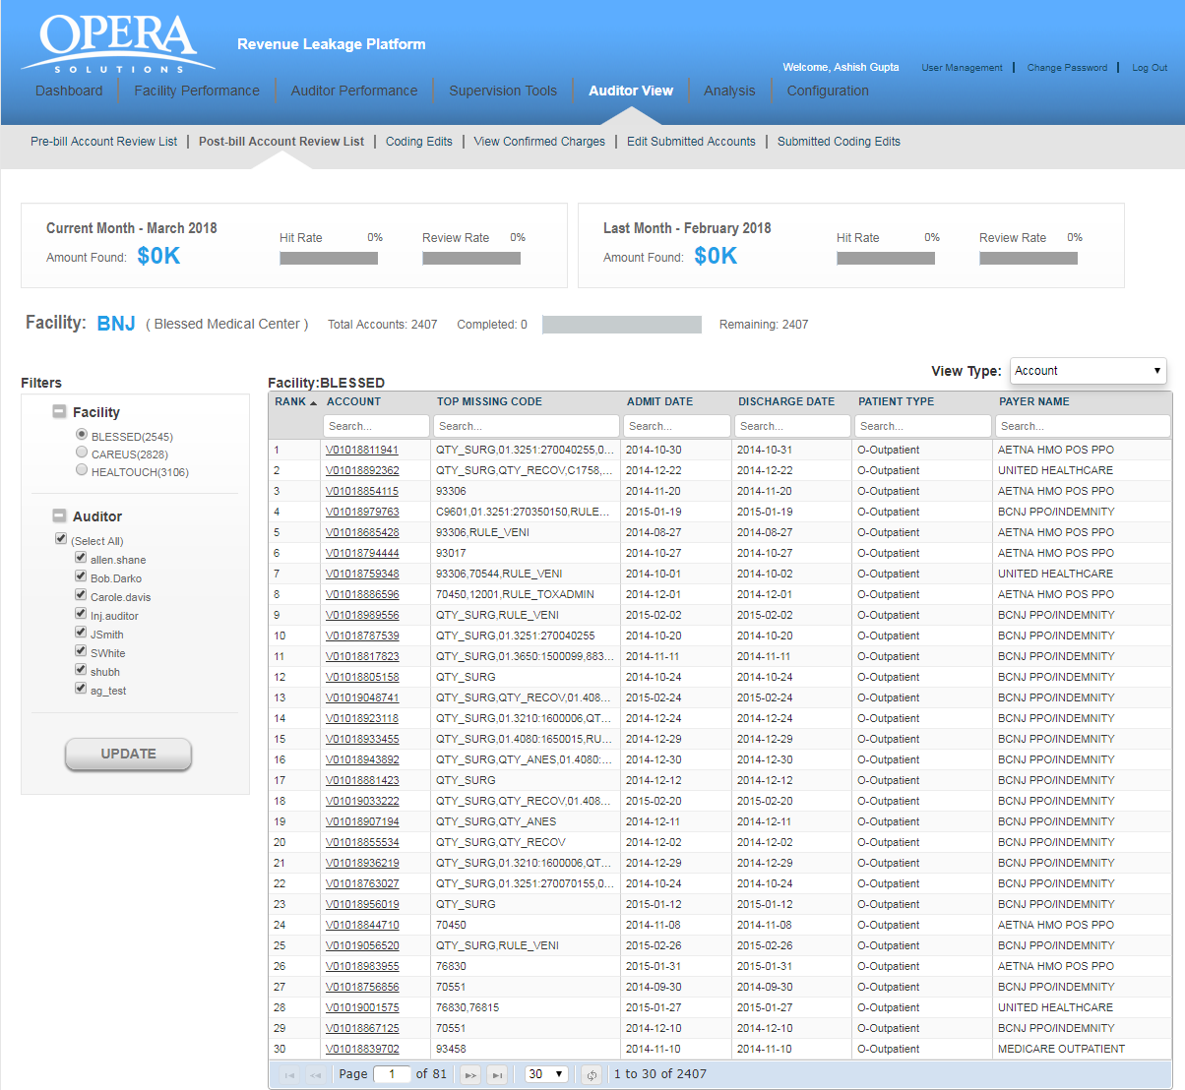

If no account is pending for review, the auditor will get the message “No Account Review is
“Pending for the Facility”.

View Type : Grouping accounts based on Code and payer. There are 3 options available in dropdown.
- Account (Default)
- Code Group
- Payer Group

Account : This the default view for showing accounts. accounts are coming based on hospitalId and accountId
Code Group: - This is showing tree view of accounts based on [hospitalId-accountid-predcodeClassifications].
Payer Group:- - This is showing tree view of accounts based on [hospitalId-accountid-PayerCode].
You will view the following details for a particular account.
- Account: It refers to the patient identification number.
- Top Missing Code: It refer to the missing code find for this account.
- Admit Date: It is the date when patient got admitted to the hospital.
- Discharge date: This is the date when patient got discharged from the hospital.
- Patient Type: There can be different types of patients. For example, OUTPATIENT, INPATIENT and EMERGENCY.
  - OUTPATIENT care is any healthcare service provided to a patient who is not admitted to a hospital.
  - INPATIENT care is any healthcare service provided to a patient who is admitted to a hospital.
  - EMERGENCY care is provided to the patients who need urgent care because of the illness or accident.
- Payer Name: This is the name of the insurance company.

All the above fields are searchable. You can navigate through multiple pages of records by making use of navigation bar given at the bottom of the screen. Enter a specific page number and you will jump to that specific page.

Above the account’s grid, you will view two widgets for other details like the Amount Found, Hit Rate and the Review Rate for the past month and the current month.
Hit Rate: It refers to the percentage of accounts on which the auditor has agreed for missing charges.
The Hit Rate of an auditor can be calculated by using the below formula:
Number of accounts Agreed / Total number of reviewed accounts

Review Rate: It refers to the percentage of accounts reviewed by the auditor.
The Review Rate of an auditor can be calculated by using the below formula:
Number of accounts Reviewed by an auditor/Total number of accounts assigned to an auditor

8.3 Coding edits Accounts

It shows all the EDITS accounts of different hospitals which have been assigned to an auditor.

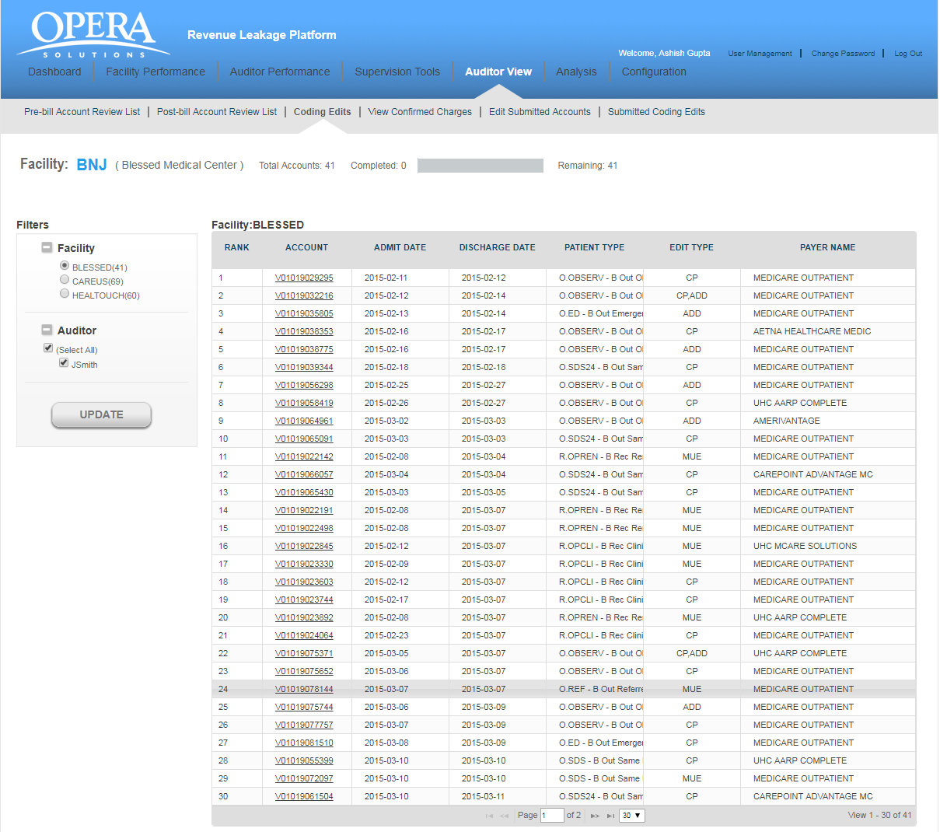

For viewing accounts of a hospital, select the hospital ID (which also shows a breakdown of accounts still to be reviewed - by each facility) and auditor from the Filter panel on the left and click on Update and the application will display all the accounts of that facility. If no account is pending for review, the auditor will get the message “No Account Review is pending for the Facility”.

You will view the following details for an account:
- Rank: It refers to the rank of that particular account for review, as calculated by Opera.
- Account: It refers to the patient identification number.
- Admit Date: It is the date when patient got admitted to the hospital.
- Discharge date: This is the date when patient got discharged from the hospital.
- Patient Type: There can be different types of patients. For example, OUTPATIENT, INPATIENT and EMERGENCY.
  - OUTPATIENT care is any healthcare service provided to a patient who is not admitted to a hospital.
  - INPATIENT care is any healthcare service provided to a patient who is admitted to a hospital.
  - EMERGENCY care is provided to the patients who need urgent care because of the illness or accident.
- Edit Type: There can be 3 different types of edit types. For example, CP, ADD, MUE
  - CP - These are set of rules which gives code pair which should not be present in the bill of a patient on the same date of service.
  - ADD An add-on code is a HCPCS/CPT code that describes a service that is always performed in conjunction with another primary service.
  - MUE - MUE for a HCPCS/CPT code is the maximum units of service that a provider would report under most circumstances for a single beneficiary on a single date of service.
- Payer Name: This is the name of the insurance company.

You can also navigate through multiple pages of records by making use of navigation bar given at the bottom of the screen.

8.4 View Confirmed charges

It provides a simple user interface that allows the auditors to evaluate a list of patient accounts for both PRE-BILL and POST-BILL. The auditor is able to view all the charges on which he has agreed/rejected during the auditing process and the amount of revenue likely to be recovered by addressing the missing charges. This way, the auditors can track the most important issues first. Supervisors can evaluate the productivity of their auditors. They can also see how entire hospitals are performing and accordingly assign the hospitals for both PRE-BILL and POST-BILL.

The auditor can select any option either PRE-BILL or POST-BILL. On selecting a particular option, the auditor can next select the hospitals which have missing charges.
Next we select the auditor in filter panel. Select the “Start Date” and the “End Date” and click on the “View” button. The application displays the data for selected time period in the tabular format. The rows which are in blue contains those predictions which are found on the account charges data after our prediction. If you do not select the “Start Date” and the “End Date” and click on the “Update” button, you will get the message “Please select both Start Date and End Date“. You may also choose to download the data by clicking on the Download button.

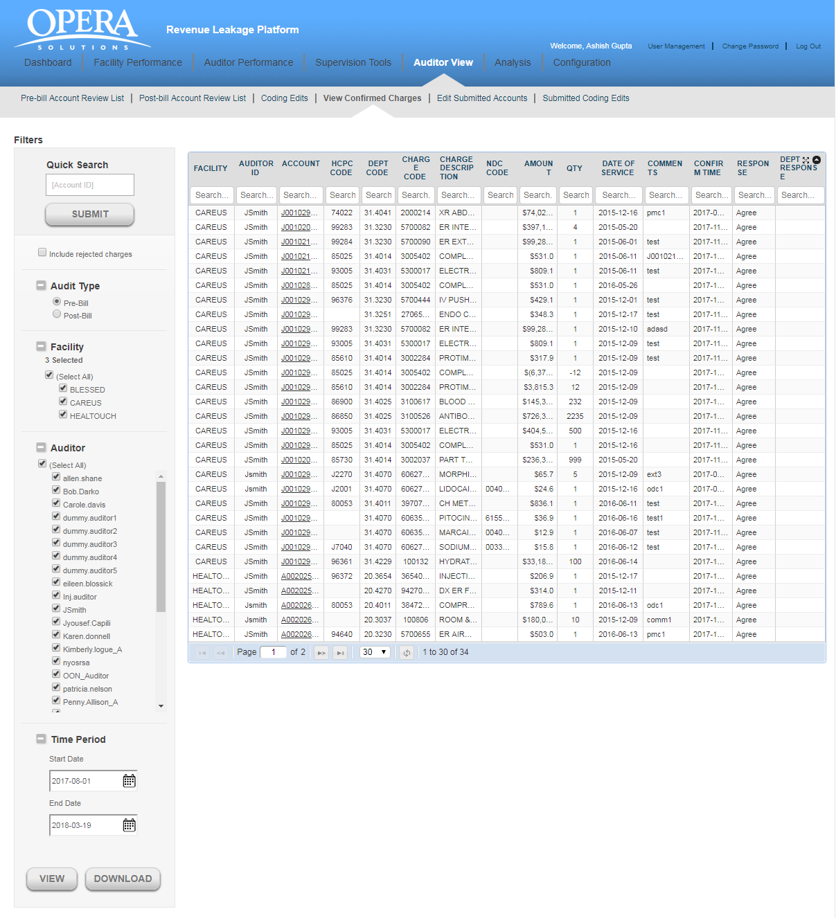

You will view the following details for each account:

- Facility: This is the hospital identification number.
- Auditor ID: This is the auditor who reviewed the prediction.
- Account: It refers to the patient identification number.
- HCPC Code: These codes are numbers assigned to every task and service a medical practitioner may provide to a patient including medical and diagnostic services.
- DEPT Code: Each department in a hospital has a specific code.
- Charge (Service) Code: Since many procedures happen in hospitals, charge code helps to identify different types of charges.
- Charge (Service) Description: This is a brief description about the charges incurred on the patient.
- NDC Code: This is a code used for identifying Pharmacy charges.
- Amount: These are missing charges which the auditor has found for an account in a facility.
- QTY: This is the quantity entered by auditor for different procedures undergone by the patient.
- Date of Service: This is the service date entered by the auditor when agreeing to the prediction
- Comments: These are the auditor’s comments about the missing charges.
- Confirm Time: This is the time when auditor confirmed the missing charges.
- Response: This is the response from the auditor

If you do not select any hospital and click on the “View” button, you will get the message “Please select at least one facility”.

If there are no missing charges found for the selected period, you will get the message “No charges found for the selected period”.

8.5 Edit Submitted Accounts

It provides a simple user interface that allows the auditors to edit their already submitted accounts for both PRE-BILL and POST-BILL. The auditor is able to view all the charges on which he has agreed/rejected during the auditing process. If the auditor feels that a change needs to be made to the submitted accounts, those accounts can be selected and the charges changed.

Caution: This functionality can be only used on the same day of submission of the account before consolidated reports are sent to facilities.
The auditor can select any option either PRE-BILL or POST-BILL. On selecting a particular option, the auditor can next select the hospitals and Auditor and click on the “Update” button. The application displays the data in the tabular format.

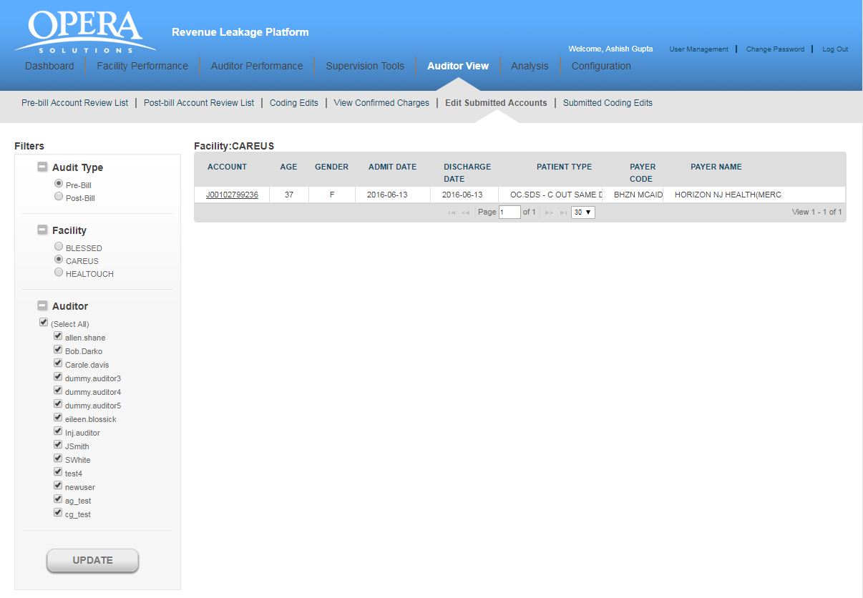

You will view the following details for each account:

- Account: It refers to the patient identification number.
- Age: It shows the age of the patient.
- Gender: It refers to the Gender of the patient.
- Admit Date: It is the date on which the patient was admitted.
- Discharge Date: It is the date on which the patient was discharged from the facility
- Patient Type: There can be different types of patients. For example, OUTPATIENT, INPATIENT and EMERGENCY.
  - OUTPATIENT care is any healthcare service provided to a patient who is not admitted to a hospital.
  - INPATIENT care is any healthcare service provided to a patient who is admitted to a hospital.
  - EMERGENCY care is provided to the patients who need urgent care because of the illness or accident.
- Payer code: Health care providers follow up on claims to insurance companies (payer) in order to receive payment for the services which they have rendered to the patients. The payer code refers to the insurance company code.
- Payer Name: This is the name of the insurance company.

If you do not select any hospital and click on the “Update” button, you will get the message “Please select at least one facility”.

If there are no account reviews found for the selected facility, you will get the message “No account review is pending for the facility”.

8.6 Submitted coding edits Accounts

It provides a simple user interface that allows the auditors to edit their already submitted accounts for CCI Edits. The auditor is able to view all the charges on which he has agreed/rejected during the auditing process. If the auditor feels that a change needs to be made to the submitted accounts, those accounts can be selected and the charges changed.

Caution: This functionality can be only used on the same day of submission of the account before consolidated reports are sent to facilities.

The auditor can select Facility and Auditor from filter panel. On selecting a particular option, the auditor can next select the hospitals and click on the “Update” button. The application displays the data in the tabular format.

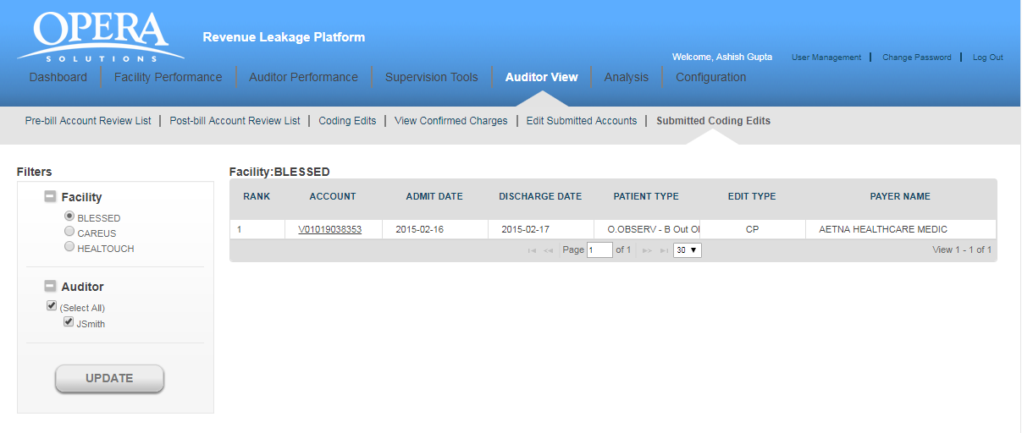

You will view the following details for each account:

- Account: It refers to the patient identification number.
- Age: It shows the age of the patient.
- Gender: It refers to the Gender of the patient.
- Admit Date: It is the date on which the patient was admitted.
- Discharge Date: It is the date on which the patient was discharged from the facility
- Patient Type: There can be different types of patients. For example, OUTPATIENT, INPATIENT and EMERGENCY.
  - OUTPATIENT care is any healthcare service provided to a patient who is not admitted to a hospital.
  - INPATIENT care is any healthcare service provided to a patient who is admitted to a hospital.
  - EMERGENCY care is provided to the patients who need urgent care because of the illness or accident.
- Payer code: Health care providers follow up on claims to insurance companies (payer) in order to receive payment for the services which they have rendered to the patients. The payer code refers to the insurance company code.
- Payer Name: This is the name of the insurance company.

You will view the following details for an account:
- Rank: It refers to the rank of that particular account for review, as calculated by Opera.
- Account: It refers to the patient identification number.
- Admit Date: It is the date when patient got admitted to the hospital.
- Discharge date: This is the date when patient got discharged from the hospital.
- Patient Type: There can be different types of patients. For example, OUTPATIENT, INPATIENT and EMERGENCY.
  - OUTPATIENT care is any healthcare service provided to a patient who is not admitted to a hospital.
  - INPATIENT care is any healthcare service provided to a patient who is admitted to a hospital.
  - EMERGENCY care is provided to the patients who need urgent care because of the illness or accident.
- Edit Type: There can be 3 different types of edit types. For example, CP, ADD, MUE
  - CP - These are set of rules which gives code pair which should not be present in the bill of a patient on the same date of service.
  - ADD An add-on code is a HCPCS/CPT code that describes a service that is always performed in conjunction with another primary service.
  - MUE - MUE for a HCPCS/CPT code is the maximum units of service that a provider would report under most circumstances for a single beneficiary on a single date of service.
- Payer Name: This is the name of the insurance company.

You can also navigate through multiple pages of records by making use of navigation bar given at the bottom of the screen.

Click on any account and you are directed to the “SUBMITTED CODING-EDITS ACCOUNT DETAILS” page.

